Throw Pink Challenge
Caddy Book
A Benefit Event for Marcia and Cheryl Peskir
Presented by Scott Family Disc Golf
Hosted by The Rock at Stonewall
November 11, 2017

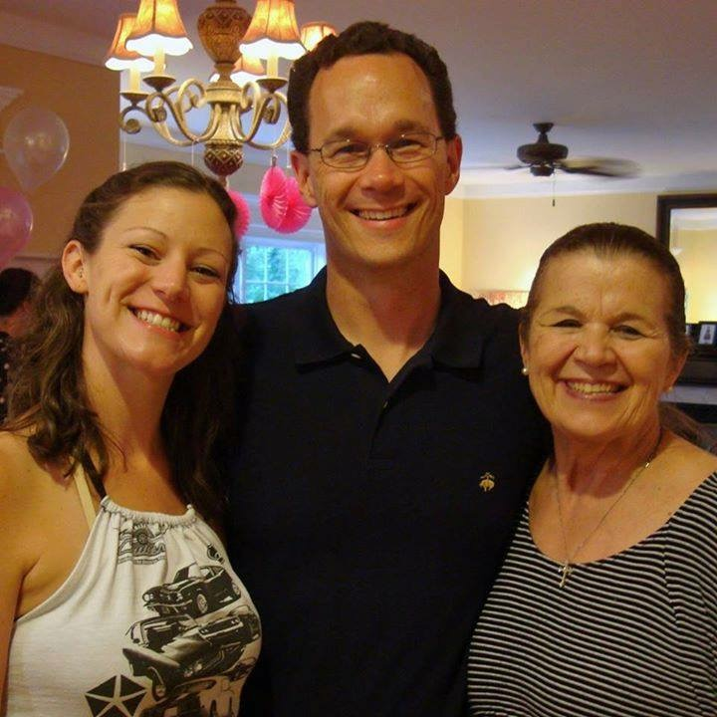

Hole pictures & distances shown are for Stonewall and will be different for this event.
Challenge details are subject to change.

Challenge #1 - Disc Crossing

Teepad:  Red teepad. | 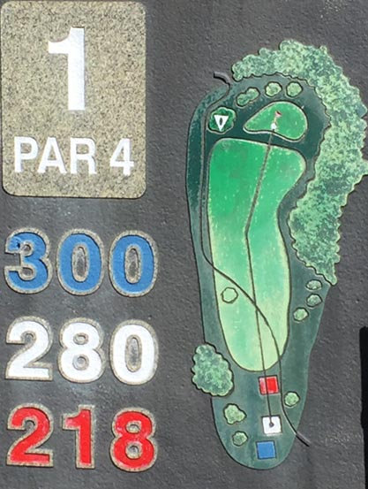
Target:

Green basket on top of hill.

Challenge:

Best Shot/Captain’s Choice (team chooses which lie to use)
Until a team’s chosen lie is beyond the pink rope, each throw must land on the opposite side of the cart path from where it was thrown.
If neither disc lands across the path, the team may select the lie to use with a 1 stroke penalty.

Partner Swap – Holes #1-6 will be played with 1 partner of your foursome, Holes #7-12 will be played with a second partner of your foursome, Holes #13-18 will be played with the final partner of your foursome.

Scoring:

Challenge Exceeded (3 points) | Team Score < 4
Challenge Passed (2 points) | Team Score < 6
Challenge Failed (1 point) | Move on to #2 after 5th throw
Challenge Not Attempted (0 points)

Challenge #2 – Driving in Style

Teepad:  Red teepad. | 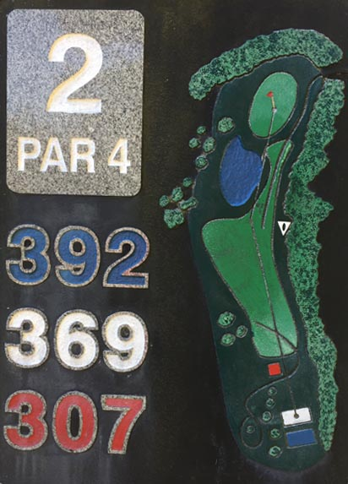
Target:

Green target on right-hand slope.

Challenge:

Best Shot Doubles.
Draw 1 die from bag, do not replace it.
Black = drive wearing innertube
Blue = drive wearing tutu & wings
White = drive wearing clown mullet wig
Red = drive wearing clown afro wig
Replace all dice in bag. Return accessories to pile (only needed for initial drive)

Pictures and/or videos of each player’s drive must be taken (and eventually sent to Debbie).

Scoring:

Challenge Exceeded (3 points) | Score = 3
Challenge Passed (2 points) | Score = 4
Challenge Failed (1 point) | Move on to #3 after 4th throw
Challenge Not Attempted (0 points)

Challenge #3 – A Small Change

Teepad:  Each player draws 1 die from the black pouch.  Show players color of die, then replace it.  Each player takes their initial drive from the teepad which matches the color of the die they drew.  (Red, White, Blue) | 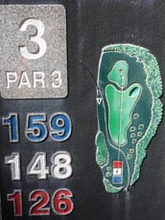
Target:

Mini basket on top of perm green target under tree.

Challenge:

Mini Challenge! Best Shot Doubles.
Players throw provided minis on every shot. Team must “hole out” in the elevated mini basket.

Return minis to teepad before moving to next hole!

Scoring:

Challenge Exceeded (3 points) | Team Score < 4
Challenge Passed (2 points) | Team Score < 7
Challenge Failed (1 point) | Move on to #4 after 6th throw
Challenge Not Attempted (0 points)

Challenge #4 - Forehand Winner

Teepad:  Drive past the red teepad.  Spray-painted teepad is directly behind where “150 yds” is spray painted on the cart path. | 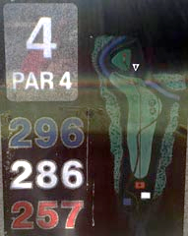
Target:

Green target on top of hill.

Challenge:

Best Shot/Captain’s Choice (team chooses which lie to use)
Sidearm ending! - Once a team’s chosen lie is beyond the rope (after cart path in the valley), each remaining throw or putt must be executed sidearm (forehand).

Scoring:

Challenge Exceeded (3 points) | Team Score < 4
Challenge Passed (2 points) | Team Score < 6
Challenge Failed (1 point) | Move on to #5 after 5th throw
Challenge Not Attempted (0 points)

Challenge #5 – Going Clubbing?

Teepad:  Red teepad | 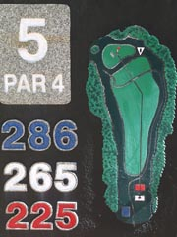
Target:

Green basket bottom of hill.

Challenge:

Ball Golf & Double Mando Challenge! Best Shot Doubles.
Any player may choose to take their initial drive using a ball golf club and golf ball instead of disc. Ball must remain in fairway to count (not in woods on either side)
Subsequent shots are played normal best shot doubles with a required double mando (trees wrapped in yellow tape) near the end of the hole.
There is no drop zone… passing through mando is required.

Leave club at teepad area, pick up balls and bring them back to clubhouse later.

Scoring:

Challenge Exceeded (3 points) | Team Score < 5
Challenge Passed (2 points) | Team Score = 5
Challenge Failed (1 point) | Move on to #6 after 5th throw
Challenge Not Attempted or mando not made (0 points)

Challenge #6 – On the Other Hand

Teepad:  Draw 1 die from bag, do not replace it.  Yellow = drive from yellow cones (4th plateau)  Blue = drive from blue teepad (3rd plateau)  White = drive from white teepad (2nd plateau)  Red = drive from red teepad (1st plateau)  Replace all dice in bag. | 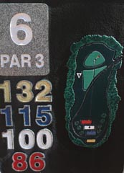
Target:

Green basket in trees to left.

Challenge:

Best Disc (play as singles, choose better score for team)
Entire hole played with non-dominant hand. (primary right-handed players must use left hand and vice versa)

Scoring:

Challenge Exceeded (3 points) | Best Disc < 4
Challenge Passed (2 points) | Best Disc < 6
Challenge Failed (1 point) | A player moves on to #10 after their 5th throw
Challenge Not Attempted (0 points)

Challenge #7 – Get a Grip

Teepad:  Teepad is a spray-painted area in front of the cart signs (which are in the middle of hole). | 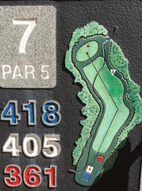
Target:

Green basket on slope on the right side of fairway.

Challenge:

Singles (combined score)
All throws must be taken while wearing an oven mitt on the throwing hand.

Partner Swap – Holes #1-6 will be played with 1 partner of your foursome, Holes #7-12 will be played with a second partner of your foursome, Holes #13-18 will be played with the final partner of your foursome.

Return oven mitts to teepad before moving to next hole!

Scoring:

Challenge Exceeded (3 points) | Combined Score < 8
Challenge Passed (2 points) | Combined Score < 10
Challenge Failed (1 point) | Move on to #8 after team’s 9th throw
Challenge Not Attempted (0 points)

Challenge #8 – Target Practice

Teepad:  Two teepads for each player!  Each player takes 1 drive from the Red teepad and another drive from the White teepad. | 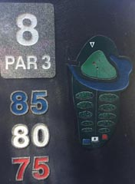
Target:

Green basket below (and surrounding area).

Challenge:

Singles (combined score)
Drive-only challenge to get as close to the target as you can from the teepad. There are no approaches or putts on this hole/challenge, only 2 drives per player.

Scoring:

Drive lands in Ball Golf Green | Score for disc = -1
Drive lands in swamp/creek | Score for disc = 0
Drive lands in on ground outside circles | Score for disc = 1
Drive lands in outer semicircle around target | Score for disc = 2
Drive lands in inner circle around target | Score for disc = 3

Challenge Exceeded (3 points) | Combined score (4 discs) > 6
Challenge Passed (2 points) | Combined score (4 discs) > 3
Challenge Failed (1 point) | Combined score (4 discs) < 4
Challenge Not Attempted (0 points)

Challenge #9 – The Rock!

Teepad:  Play Rock-Paper-Scissors with your partner.  Next, the 2 winners play again against each other and the 2 losers play against each other.  2 wins = special short spray-painted teepad  1 win, 1 loss = Throw from red teepad  2 losses = throw from back blue teepad | 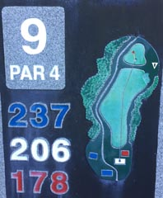
Target:

Green basket on THE ROCK on top of hill to the right.

Challenge:

Best Disc (play as singles, choose better score for team)
Each player completes the hole (based upon their teepad & target) as if it were singles.

Scoring:

Challenge Exceeded (3 points) | Best Disc < 4
Challenge Passed (2 points) | Best Disc < 6
Challenge Failed (1 point) | A player moves on to #10 after their 5th throw
Challenge Not Attempted (0 points)

Challenge #10 – Ladies & Gents

Teepad:  Adult Males: Red  Women/Juniors: Blue | 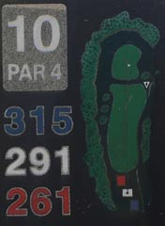
Target:

Adult Males: Green
Women/Juniors: White

Challenge:

Best Disc (play as singles, choose better score for team)
Each player completes the hole (based upon their teepad & target) as if it were singles.

Scoring:

Challenge Exceeded (3 points) | Best Disc < 4
Challenge Passed (2 points) | Best Disc < 6
Challenge Failed (1 point) | A player moves on to #11 after their 5th throw
Challenge Not Attempted (0 points)

Challenge #11 – Alternate Shot

Teepad:  Red teepad. | 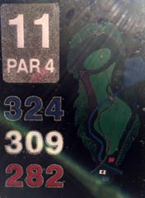
Target:

Green basket under tree.

Challenge:

Alternate Shot!
Team chooses player to drive first. Partners then alternate throwing from their team’s last lie until they “hole out”.

Creek and beyond is Out of Bounds. Bring lie back into line of play with 1 stroke penalty.

Scoring:

Challenge Exceeded (3 points) | Team score < 4
Challenge Passed (2 points) | Team score < 6
Challenge Failed (1 point) | Team score > 5
Challenge Not Attempted (0 points)

Challenge #12 – Barnstorming!

Teepad:  Red teepad. | 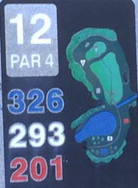
Target:

Green basket beyond barn.

Challenge:

Best Disc (play as singles, choose better score for team)

Players must pass through 2 sets of triple mandos to the right of the barn.

Scoring:

Challenge Exceeded (3 points) | Best Disc < 5
Challenge Passed (2 points) | Best Disc = 5
Challenge Failed (1 point) | A player moves on to #13 after their 5th throw
Challenge Not Attempted (0 points)

Challenge #13 – Tough Shot

Teepad:  Each player draws 1 die from the black pouch.  Show players color of die, then replace it.  Each player takes their initial drive from the teepad which matches the color of the die they drew.  (red, white, or blue) | 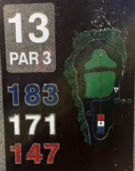
Target:

Green basket beyond creek.

Challenge:

Tough shot doubles! Players must take the worst of their 2 throws (as determined by other team) until one of them “holes out”.
Creek is NOT Out of Bounds.

Partner Swap – Holes #1-6 will be played with 1 partner of your foursome, Holes #7-12 will be played with a second partner of your foursome, Holes #13-18 will be played with the final partner of your foursome.

Scoring:

Challenge Exceeded (3 points) | Team score < 4
Challenge Passed (2 points) | Team score < 5
Challenge Failed (1 point) | Team score > 4
Challenge Not Attempted (0 points)

Challenge #14 – Short or Long

Teepad:  Draw one sided die from black pouch “14A”.  Show other players, then replace the die.  Take your first drive from that color teepad.  (white or red) | 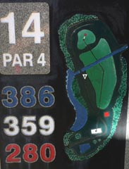
Target:

Draw one 6-sided die from black pouch “14B”.
Show other players, then replace the die.
The color you draw is the color target for you.
(white or green)

Challenge:

Singles (combined score)
Each player completes the hole (based upon their teepad & target) as if it were singles.
No OB or mando in play.

Scoring:

Combine your score with your partner’s score.
Challenge Exceeded (3 points) | Combined score < 7
Challenge Passed (2 points) | Combined score < 10
Challenge Failed (1 point) | Combined score > 9 (Move on to #15 after team’s 9th throw)
Challenge Not Attempted (0 points)

Challenge #15 – Leading the Blind

Teepad:  Continue on cart path past the red teepad to a spray-painted tee pad on the left side (near end of paved path). | 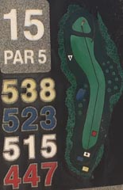
Target:

First white basket on hill in front and to the right of teepad.

Challenge:

This hole is to be played blindfolded!
Each team choose 1 partner to be blindfolded and the other partner to be the “guide”.
Take a tour towel, fold it in half horizontally, and tie it around the thrower’s eyes.
The “guide” can guide them physically by the hand, or verbally into position for each throw, providing them with any description needed for them to execute the throw without being able to see.

SAFETY ALERT! – Guides, make sure that all players are clear of any throws or hazards for the entirety of this hole!

Return towels/blindfolds to teepad before moving to next hole!

Scoring:

Challenge Exceeded (3 points) | Score < 4
Challenge Passed (2 points) | Score < 7
Challenge Failed (1 point) | Score > 6 (move to next hole if 6th shot not made)
Challenge Not Attempted, or blindfold removed early (0 points)

Challenge #16 – Throw Pink!

Teepad:  Red teepad. | 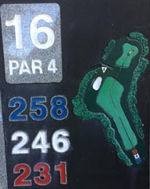
Target:

Green basket.

Challenge:

Best Shot/Captain’s Choice (team chooses which lie to use)
Throw Pink Disc Challenge! Every throw must be made with a pink disc if possible.
If a player does not have a pink disc, they can use another player’s if they have extra.
On any shot, a player may throw a non-pink disc of their choice, provided that they release that disc upside down!

Once a chosen lie is inside the island/peninsula area (in the woods, marked by cart path and white lines) around the target, all putts must be “turbo putts” (both spin and flip methods are allowed).

Scoring:

Challenge Exceeded (3 points) | Team score < 5
Challenge Passed (2 points) | Team score < 7
Challenge Failed (1 point) | Team score > 6
Challenge Not Attempted (0 points)

Challenge #17 –Jailbreak

Teepad:  Each player draws a die, shows it to the other players, then replaces it.  Everyone who drew a black die, makes their first throw from the “jail” area.  Everyone who drew a yellow die, “gets out of jail free” and may drive from the plateau in front of “jail”. | 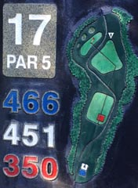
Target:

Green basket far down the hill.

Challenge:

Get Out of Jail! (3 of the 4 dice are black)
Best shot doubles.

Scoring:

Challenge Exceeded (3 points) | Best shot doubles score < 5
Challenge Passed (2 points) | Best shot doubles score < 7
Challenge Failed (1 point) | Best shot doubles score > 6 (Move on to #18 after team’s 6th throw)
Challenge Not Attempted (0 points)

Challenge #18 – Vertically Challenged

Teepad:  Each player draws 1 die from the black pouch.  Show players color of die, then replace it.  Each player takes their initial drive from the teepad which matches the color of the die they drew.  (red or blue) | 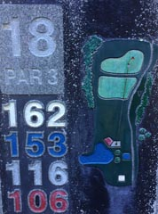
Target:

Green basket on top of hill.

Challenge:

Initial drive must be released vertically. (tomahawk, thumber, underhand)
Play this hole as if it were singles.

Scoring:

Combine your score with your partner’s score.
Challenge Exceeded (3 points) | Combined score < 7
Challenge Passed (2 points) | Combined score < 10
Challenge Failed (1 point) | Combined score > 9 (Move on to #1 after team’s 9th throw)
Challenge Not Attempted (0 points)

Format by Hole

1 – Captain’s Choice (Best Shot) | 10 – Best Disc
2 – Best Shot | 11 – Alternate Shot
3 – Best Shot | 12 – Best Disc
4 – Captain’s Choice (Best Shot) | 13 – Tough Shot
5 – Best Shot | 14 – Singles (Combined Score)
6 – Best Disc | 15 – Singles (Special Assistance)
7 – Singles (Combined Score) | 16 – Captain’s Choice (Best Shot)
8 – Singles (Combined Score) | 17 – Best Shot
9 – Best Disc | 18 – Singles (Combined Score)

Glossary & Definitions
Alternate Shot – Each team selects a player to throw the tee shot. The other player then throws from the subsequent lie, and play alternates in that fashion until the hole is completed.

Best Disc – (also known as Best Score), each player plays the hole as they would while playing singles; there are no shared lies. The team score is the best score on the hole by one of its players.

Best Shot Doubles – Both players throw from each lie (starting with the tee shot), then the team chooses which of the resulting lies to continue play from, until the hole is completed.

Captain’s Choice – Essentially the same as Best Shot Doubles. Used in this event & caddy book just to highlight holes where the closest disc may not be the best disc (for example choosing a further disc over a closer one to delay a challenge from starting).

Hole Out - To successfully complete play of a hole.

Lie - The spot on the playing surface behind the marker, upon which the player takes a stance in accordance with the rules.
Mando (Mandatory) - An object or objects that the disc must pass in a designated manner.

Singles (combined score) – Format where both partners play the hole out as if it were singles, then simply add their scores together.

Tough Shot Doubles – Tough Shot is the same as Worst Shot, with the following variation: once a player on the team has holed out, the team has completed the hole.

Thank you to all our sponsors that made this event possible!

Company & Organization Sponsors

Throw Pink | The Rock Disc Golf Course | Scott Family Disc Golf
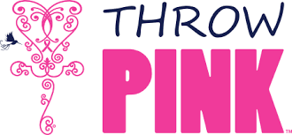 |  | 
Innova Discs | Paragon Disc Golf | United Chains
 |  | 
Ladies First Disc Golf | Queens of the City Disc Golf | BAD Family Disc Golf
 |  | 
Bang Chains | Indian Land Disc Golf | Skeet Scienski
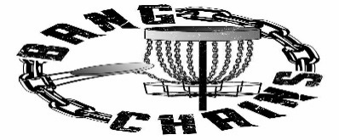 |  | 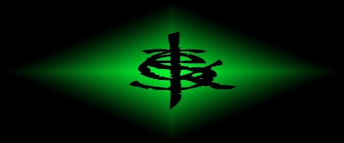

Individual Sponsors
Andrew Atwood | Brian Mace | Chuck Connelly | Daniel Sparta
Dave Reed | Delores Shivar | Don Tennyson | Donny Paris
Gary Morris | Joe Rotan | Michael Williams | Michelle Ramseth
Ryan Hunt | Sara Lamberson | Sarah Hokom | Theresa Cunningham
Tony & Patricia Cisco

